Final Project-4

ABC Call Volume Trend Analysis

PLEASE DOWNLOAD THE EXCEL FILE IN THE FOLDER WITH THE NAME “Final Project-4

ABC Call Volume Trend Analysis” for all the details.

# Project Description:

Businesses may have a local, regional, national, or international target audience, or a combination of them. Thus, they market in various methods. Advertising is a technique for promoting your company in order to boost sales or raise audience awareness of your goods or services. Your advertising may contribute to the formation of a customer's initial perceptions of your company before they interact with you directly and make a purchase of your goods or services. The advertising industry is particularly cutthroat because many players would spend a lot of money to target the same market. One of the many ways to improve the business is by taking insights from the customers also called the Customer Experience (CX). A customer experience (CX) team is made up of experts who examine data and consumer input before sharing their findings with the rest of the company. These teams typically carry out a variety of duties to analyze Customer Experience Data.

# Approach:

For this project as there happens to be only one dataset it is best to go with a sequential approach where we solve all the given problems one after the other which will help me have better coherence and cohesion with the topic and the task.

# Tech Stack:

Software used: Microsoft Excel

Version: 2103 (16.0.13901.20400)

Developer: Microsoft

Latest Stable Release: April 13, 2021

Purpose: To perform data analysis.

Written in: C++(back-end)

PLEASE DOWNLOAD THE EXCEL FILE IN THE FOLDER WITH THE NAME “Final Project-4

ABC Call Volume Trend Analysis” for all the details.In the file each task is solved in a different sheet. The sheet name represents which solution it contains. Example sheet “B” is a solution for task “B”

# Task/Solution:

1. **Calculate the average call time duration for all incoming calls received by agents (in each Time_Bucket).**

**Sol:** The average can be easily calculated by sum of all the duration of calls in a particular time bucket and total number of calls in that time bucket.

| Time Bucket | Average Duration |
| --- | --- |
| 9_10 | 3.27 |
| 10_11 | 3.37 |
| 11_12 | 3.28 |
| 12_13 | 3.15 |
| 13_14 | 3.19 |
| 14_15 | 3.18 |
| 15_16 | 3.25 |
| 16_17 | 3.28 |
| 17_18 | 3.27 |
| 18_19 | 3.35 |
| 19_20 | 3.37 |
| 20_21 | 3.36 |

1. **Show the total volume/ number of calls coming in via charts/ graphs [Number of calls v/s Time]. You can select time in a bucket form (i.e. 1-2, 2-3, …..)**

**Sol:** The total v/s number of calls graphs can be drawn by finding in totals in each bucket:

| Time Bucket | No_of_calls_answered |
| --- | --- |
| 9_10 | 3546 |
| 10_11 | 4957 |
| 11_12 | 6760 |
| 12_13 | 8080 |
| 13_14 | 7691 |
| 14_15 | 6845 |
| 15_16 | 6919 |
| 16_17 | 7063 |
| 17_18 | 6848 |
| 18_19 | 5542 |
| 19_20 | 3886 |
| 20_21 | 2436 |

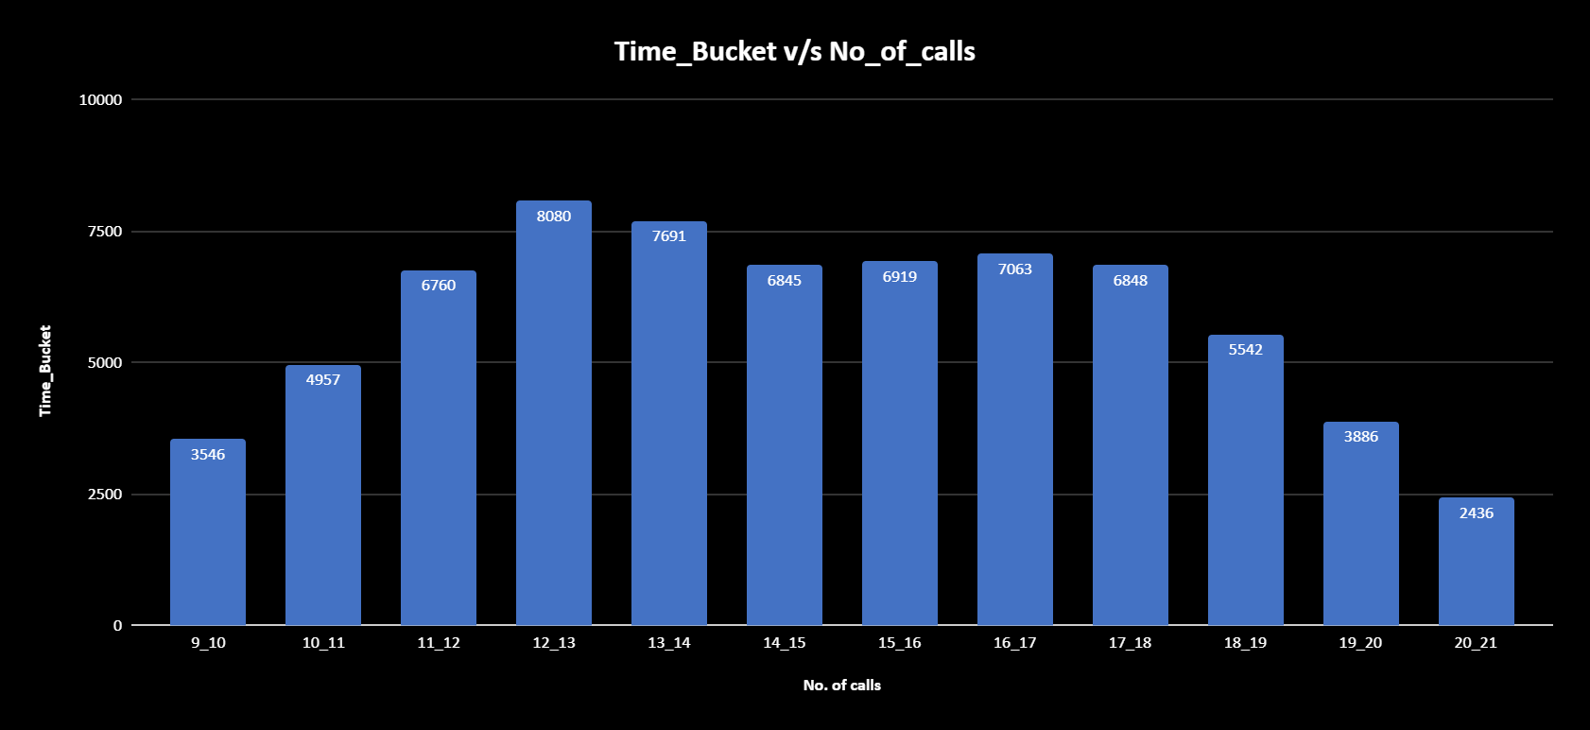

A graph in ascending order of no_of_calls:

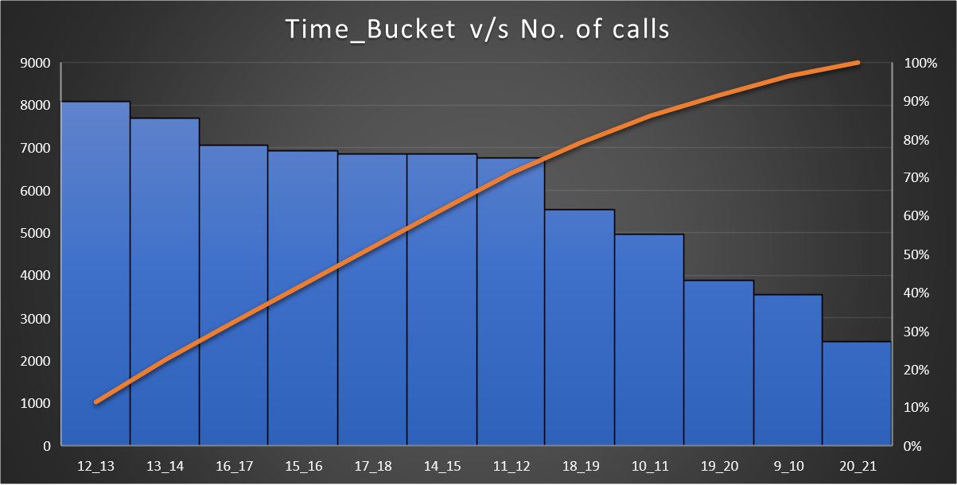

1. **As you can see, the current abandonment rate is approximately 30%. Propose a manpower plan required during each time bucket [between 9am to 9pm] to reduce the abandon rate to 10%. (i.e. You have to calculate the minimum number of agents required in each time bucket so that at least 90 calls should be answered out of 100.)**

**Sol:**

We can see that the current abandonment rate is 30% with about 34404 from the total calls being abandoned but when we want to reduce the abandonment rate to 10% which is 11799 out of 117989. Also, 65 executives in total have at present, now we should calculate the minimum number of people required for reducing it to 10% i.e. 11799 which is about 83 executives

| Column1 | Total Number of Executives | Total calls | No. of abandoned calls | % of abandon |
| --- | --- | --- | --- | --- |
| Present Case (30%) | 65 | 117989 | 34404 | 0.2915865038 |
|  |  |  |  |  |
| 10% Case | 83 | 117989 | 11799 | 0.1 |
|  |  |  |  |  |
| In each Time_Bucket | 6 |  |  |  |

1. **Let’s say customers also call this ABC insurance company at night but don't get an answer as there are no agents to answer, this creates a bad customer experience for this Insurance company. Suppose every 100 calls that customer made during 9 Am to 9 Pm, customer also made 30 calls in night between interval [9 Pm to 9 Am] and distribution of those 30 calls are as follows:  
     
     
     
   Now propose a manpower plan required during each time bucket in a day. Maximum Abandon rate assumption would be the same 10%.**

**Sol:** Here we are finding the manpower required for rate of abandonment to 10% which is about 106190 calls being answered, also it is given that of 100 calls come in the day then 30 calls come in the night which is about 31857 calls which are to be answered hence it is a simple calculation where we know 106190 calls had 65 executives then 31857 calls would need how many, which would turn out to be 20 executives with the following in each bucket.

| Time_Bucket | No_of_calls_if_30 | No_of_calls_actually | No_of_executives |
| --- | --- | --- | --- |
| 21_22 | 3 | 4779 | 3 |
| 22_23 | 3 | 4779 | 3 |
| 23_24 | 2 | 3186 | 2 |
| 24_1 | 2 | 3186 | 2 |
| 1_2 | 1 | 1593 | 1 |
| 2_3 | 1 | 1593 | 1 |
| 3_4 | 1 | 1593 | 1 |
| 4_5 | 1 | 1593 | 1 |
| 5_6 | 3 | 4779 | 3 |
| 6_7 | 4 | 6372 | 4 |
| 7_8 | 4 | 6372 | 4 |
| 8_9 | 5 | 7965 | 5 |

# Insights:

Insights refers to accurate understanding of something. These points helps in an insightful understanding of the problems:

* All the problems refer to real-life situations which any data analyst would face while dealing with data. The attributes may differ but the application or approach will not change.
* The dataset in this project refers to calls an insurance company has received at different times of the day, the duration it lasted and many other attributes.
* There are about 117989 records and about 14 attributes.
* It all accounts for the Customer Experience [CX] and the stats that are derived from the dataset are really helpful to get the solutions for the questions.
* The data helped in many types of analysis possible and draw insights

# Result:

To recapitulate, the results are elaborately discussed above, moreover this project/task helped me in better understanding of Excel and its limitations. It also enhanced my Critical Thinking and Problem-Solving skills. (I could not solve all the questions by using joins. However I managed to draw conclusions using other concepts which are hopefully right).

Thank You.